Sending out a File Request

Quick Guide

Contents

1 Introduction to File Request 3

2 How does it work 3

2.1 Start creating pre-drafts 3

2.2 Optional: Merge file 4

2.3 Send out file request 5

2.4 Monitor if the file request is accepted and the technical file has been shared. 7

2.5 Review shared file 9

2.6 Reject the file 10

2.7 Accept the file 11

3 What if 14

3.1 I have company-specific requirements 14

3.2 Merged incorrectly 14

3.3 Delete pre-drafts 15

4 Tips 15

4.1 Create tabs 15

4.2 Create a template text 15

# Introduction to File Request

Through the platform, you can ask your supplier to share a complete technical file. Your supplier is responsible for creating the file and collecting the correct documents to show your product's compliance. Once the file is complete, he shares the technical file.

Benefit:

While using the pre-drafts to request the file, you will gain a comprehensive overview of the articles that have not yet received the necessary documentation. This overview allows you to track the status of your requests effectively. Additionally, it provides valuable insights into your supplier’s performance, including the speed with which they responded to your initial request. You will be able to assess their follow-up time. This can help you assess your future supplier relationship.

# How does it work

1. Start creating pre-drafts
2. Optional: Merge file
3. Send out file request
4. Monitor if the file request is accepted and shared
5. Review shared file
6. Reject file
7. Accept file

## Start creating pre-drafts

There are several options:

1. Via the import function add the pre-drafts to the account

More [information](https://www.productip.com/kb/productipedia/tutorials/excel-import-product-data/) import excel

1. CSV import

Check with your account manager

1. Create it with the “Create a new Technical file” button

And select “Create pre-draft file” in the bottom right corner

Check if all information is available in the pre-draft.

In this example, the supplier information is missing.

* Select the file(s)
* Choose action “update supplier contact”
* Click Execute
* A screenshot of a contact

  Description automatically generatedSearch for the supplier
* Select correct contact
* Click Save

## Optional: Merge file

Articles can be merged into one technical file.

There are some restrictions for this.

- Same supplier

- Same material

- Same list of Requirements (function)

- Same documents

* Although the articles may have different market release dates, you can merge them into a single file as long as there are no new requirements applicable for the new batch.

However, while this approach may seem convenient in the short term, it could generate additional work for future orders. Therefore, it’s important to carefully consider your options to ensure you choose the most effective long-term solution!

*Your supplier may use various factories for different batches, so it's essential to create a unique file for each batch. This keeps everything organized and ensures accuracy!

In case of doubt, double-check with your supplier before merging.

1. Select the articles that can be merged
2. Choose action: “merge files”
3. Click execute

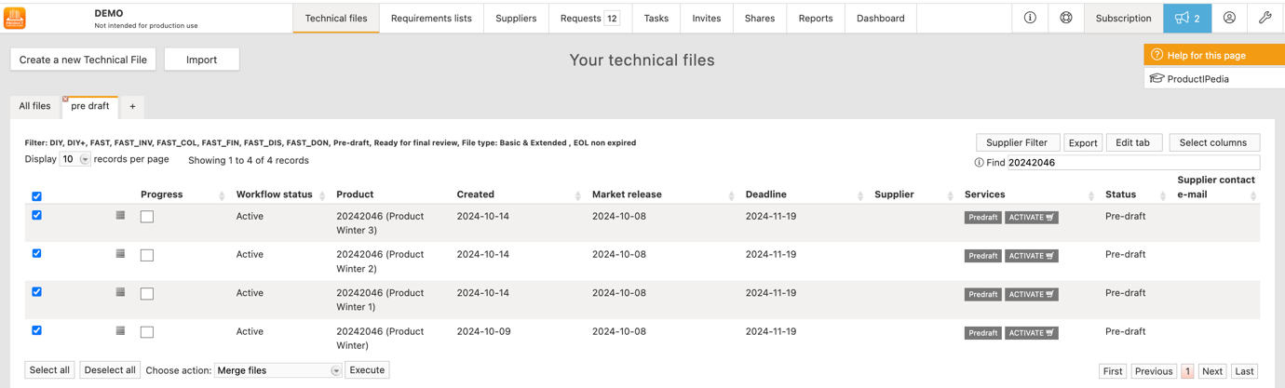

Your suppliers are unable to merge the files on his side, so when you both agree that the files can be merged, we advise your supplier to decline the requests and ask you to merge the pre-drafts.

## Send out file request

You have two options for submitting the product requirements to the file.

1. you can send the request and allow your supplier to complete the necessary product specifications themselves.
2. you can choose to fill in the details on your own. If you prefer, you can specify just the regions where the products will be sold and leave the the product category open for your supplier to complete.

It's important to note that your supplier cannot alter any information you have specifically provided, when it is a prepaid file request.

The regions can also be added to the file with the import of the product data.

The product category always has to be added manually, because you also have to go through the Q & A.

* In Batch:
* Select the file for the supplier (you can use the supplier filter for this)
* Select the technical files
* Choose action

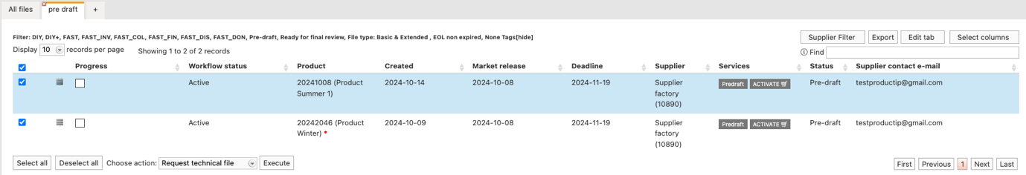

You Can select a template text, to set this, click Manage templates

For Enterprise accounts it is possible to send a prepaid request. Tick the box to send a prepaid technical file request.

* Per file
* Open the file
* You can already add the “Product requirements information”

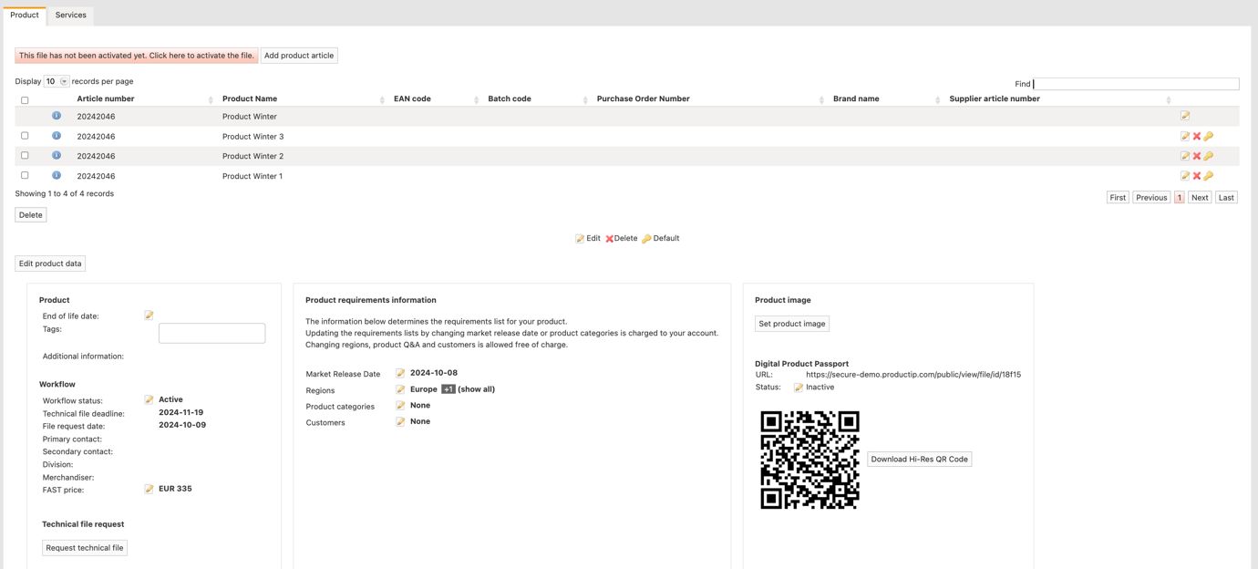

* Click “Request technical file”

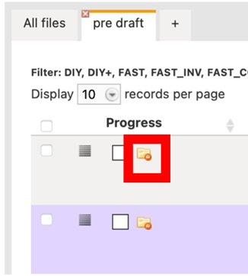When your supplier declines the request, you will receive an email (when you have sent the request).

And the file will be marked with a declined icon

In the Timeline tab of the file, you can find the message explaining why the file was declined.

## Monitor if the file request is accepted and the technical file has been shared.

Via tabs, you can easily find the files per status

for more information on how to create tabs, click [here](https://www.productip.com/kb/productipedia/tutorials/technical-files/custom-tabs)

For Pending file requests, you must remind the supplier to accept the request.

* In Batch

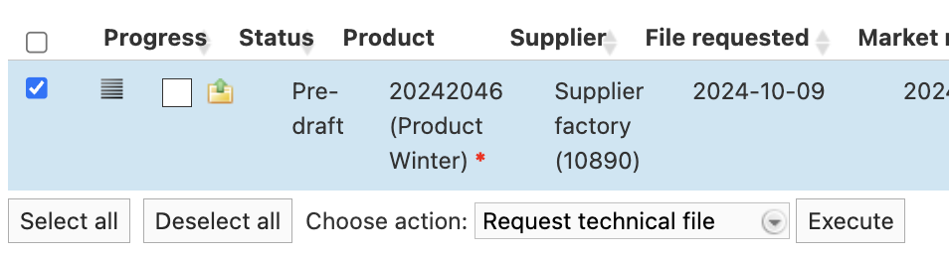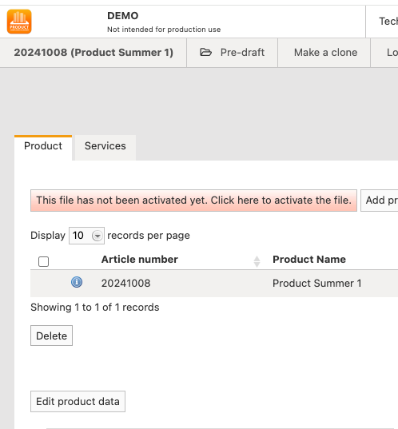

* Per file
* Open the file
* Click on the envelope icon

If the supplier has not responded after this reminder, it’s important to proactively contact them via telephone or email to encourage them to share the technical file.

## A screenshot of a computer Description automatically generatedReview shared file

On the Request tab you can find the shared file

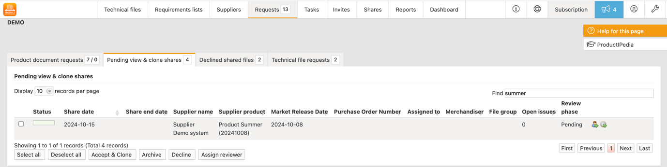

The System will indicate if there is a difference between the information in the pre-draft and the received file

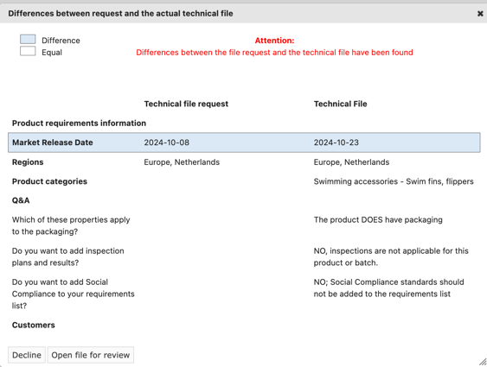

Here, you can directly Decline the technical file or open the technical file to review it

Open the file.

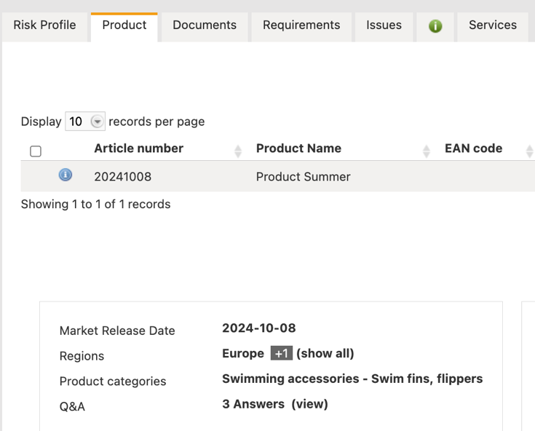

* Review the information
* Check the product category
* Check Q & A

This information determines the requirements on the requirements tab. Any mistake here can lead to a wrong or incomplete requirements list.

* Look at the Documents tab and Requirements tab

## Reject the file

When you find that you can’t accept the file, add an issue to inform your supplier of what should be improved in the file.

* Go to the Issues tab
* Add issue

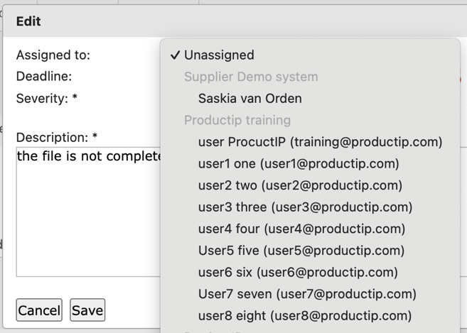

Supplier info

When you assign the issue to the supplier, it will be added to his issues list in his account. And your supplier will receive an email.

* Decline the file

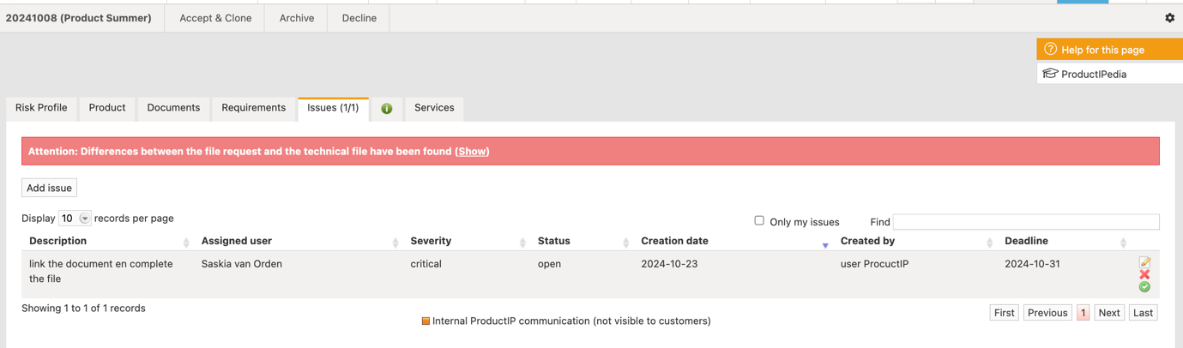

Your supplier will receive this as an email.

The file is no longer accessible for you and can be found on

the tab declined shared files.

When you decline the technical file that your supplier has shared, the status of the technical file request in the pre-draft will be reset to accepted, and the pre-draft can be found on the tab “accepted file request.”

The file can be found on this tab, which helps you to monitor what files you still need to receive a technical file from the supplier.



## Accept the file

When you accept the file

* Click the button “Accept & Clone”
* The system will find the pre-draft which matches the file request
* Don’t forget to tick the box to merge this pre-draft with the shared file

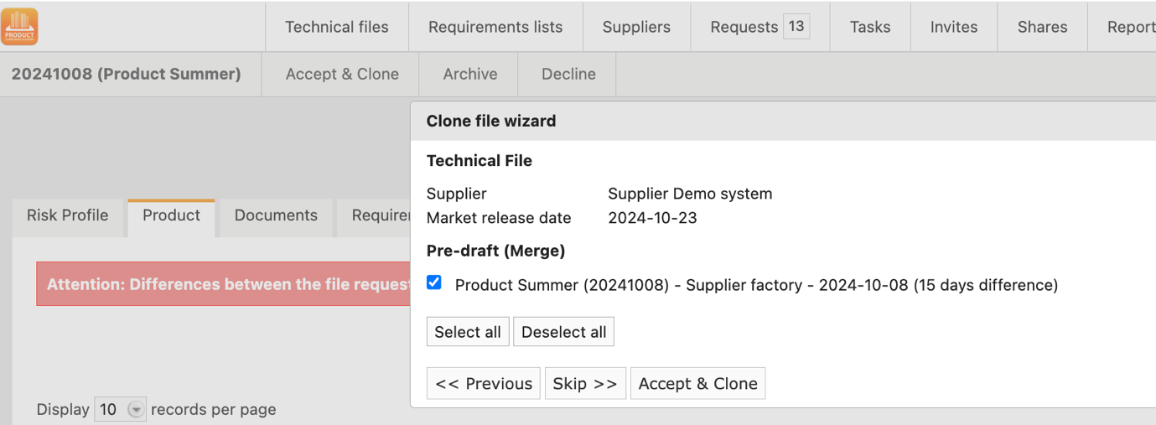

The file will be copied into your account and can be found on the technical file page.

In this case the market release date (mrd) from the shared technical file has overwritten the

MRD of the pre-draft.

When your supplier changes anything in his technical file, this will not be visible in your file.

This has now become a new technical file, which you can work on.

It could be that you have to create the EU DOC.

This can be done in reviewed status, when you have to work on the technical file you have to set the file to draft

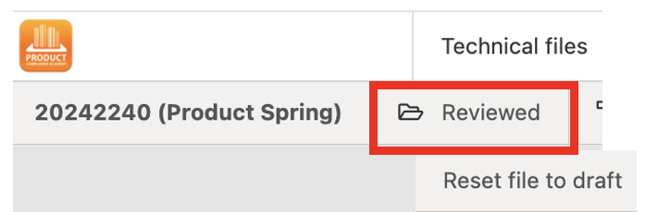

# What if

## I have company-specific requirements

For Enterprise accounts, specific requirements unique to the company can be included. These additional requirements will be added to the requirements list. Please note that ProductIP is not responsible for monitoring or updating these requirements.

Additionally, a document can be attached to these requirements, which will be accessible to the supplier as a resource. The supplier can then use this document to complete and add to the file.

It is important that you add yourself as a customer to your account. Then, when you send the technical file request, the company-specific requirement will automatically be visible to the supplier.

After ProductIP has added the company-specific requirement for your company, follow the steps below to set the customer.

* Go to control panel
* Select Company account
* Select Customer
* Add customer
* Select your company

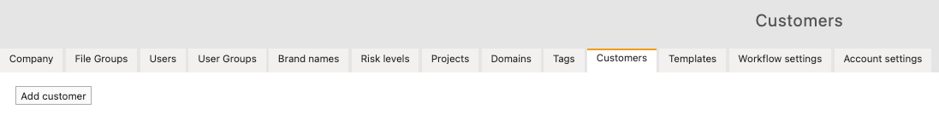

## Merged incorrectly

* Clone the pre-drafts with the merged articles as many times as necessary
* A screenshot of a computer

  AI-generated content may be incorrect.Open the pre-draft
* Click “make a clone”
* A screenshot of a phone

  AI-generated content may be incorrect.Delete the articles in the files

## Delete pre-drafts

* Select the pre-drafts
* Choose action delete pre-drafts (bottom of the page)
* Click Execute

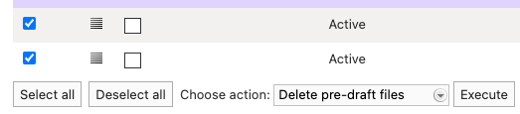

# Tips

## Create tabs

<https://www.productip.com/kb/productipedia/tutorials/technical-files/custom-tabs>

## Create a template text

* Go to Control panel
* Select Company account
* A screenshot of a computer

  Description automatically generatedSelect Templates
* Click “Create new template”
* Select Technical file request

